Tasks Manger

Division of Labor

**姓名 伊万**

**学号 6318000299**

**姓名 叶寒**

**学号 6318000426**

**姓名 胡萨**

**学号 6318000428**

**姓名 叶得力**

**学号 6317000079**

|  |  |  |  |  |
| --- | --- | --- | --- | --- |
| Name\Task | **伊万** | **叶寒** | **胡萨** | **叶得力** |
| 1 | Back-end  (Controllers,  Services) | Back-end  (DB, Entities) | Front-end  (Sign-in, sign-up pages, users page) | Front-end  (home page, projects page, tasks) |
| 2 | Testing HTTP requests | Testing DB requsts | Testing UI, design | Testing UI, design |
| 3 | Writing reports | Writing reports | Writing reports | Writing reports |
|  |  |  |  |  |

签字：

组长：**伊万 ** 同学：**叶寒** 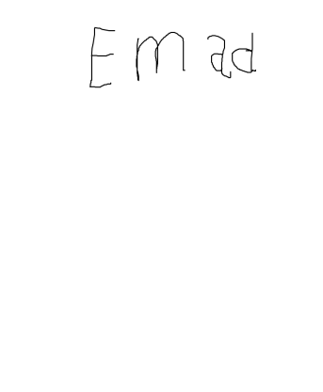

同学：**胡萨** 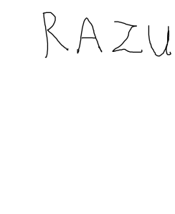 同学：**叶得力 **